Multi-Task Deep Learning for Food Recognition and Nutrition Estimation from Food Images
Received: 20 June 2026; Revised: Accepted: xxxx; Available online: xxxx
Abstract: In recent years, monitoring nutritional intake has become increasingly important for promoting healthy dietary habits and reducing the risk of diet-related diseases. This research presents a deep learning–based end-to-end multi-task learning framework for simultaneous food recognition and nutrition estimation from 2D food images. A cleaned and augmented subset of the NutritionVerse-Real dataset was used, comprising 889 images across 42 food classes after removing three classes with insufficient samples. The proposed architecture employs a shared convolutional neural network backbone with two prediction branches: a multi-label classification head using sigmoid activation to identify the food components present in a dish, and a regression head that estimates five dish-level nutritional targets (calories, fats, carbohydrates, protein, and sodium). The model is trained using a weighted combined loss that balances weighted binary cross-entropy for food classification and a per-nutrient weighted Huber loss for nutrition regression. Two backbone architectures, MobileNetV2 and ResNet-50, were evaluated within this framework using a two-stage transfer-learning strategy and backbone-specific task-loss weighting. For food recognition, ResNet-50 achieved higher micro recall (0.5273) and micro/macro F1-scores (0.4979/0.3905), whereas MobileNetV2 attained higher micro precision (0.5034), Hamming accuracy (0.9132), and micro AUC (0.8938). For nutrition estimation, both backbones produced positive R² values across all five targets. Sodium was the most predictable nutrient, with R² values of 0.613 for MobileNetV2 and 0.691 for ResNet-50, followed by carbohydrates, with R² values reaching 0.290, while calories, fats, and protein remained more challenging, with R² values between 0.05 and 0.19. The two architectures exhibited complementary strengths rather than clear overall superiority: MobileNetV2 performed better for calories and fats, whereas ResNet-50 performed better for carbohydrates, protein, and sodium. These findings demonstrate the feasibility of simultaneous food recognition and nutrition estimation from a single 2D food image, while confirming that portion-dependent nutrients remain a principal limitation of 2D-only approaches. The results provide a foundation for future automated dietary monitoring systems and further research on image-based nutrition assessment.
Keywords: Dietary Monitoring; Deep Learning; MobileNetV2; Multi-Task; Nutrition Prediction; ResNet-50

- INTRODUCTION
The increasing prevalence of diet-related diseases such as obesity, diabetes, and cardiovascular conditions has led to growing interest in automated food nutrition estimation systems [1]. Traditional methods require manual logging of meals, which is time-consuming and error-prone [4, 7]. With the advancement of computer vision and deep learning, image-based nutrition estimation has become a promising approach to understanding eating behavior and supporting health-conscious decisions [3, 6].
Although much progress has been made in image-based food classification, most widely used benchmark datasets focus on Western cuisines [7], while Southeast Asian dishes are frequently mixed, contain multiple ingredients, and lack consistent presentation styles remain under-represented [5]. Datasets such as Food-101 and Food-50 do not capture the visual diversity of Southeast Asian dishes, resulting in poor performance when models are applied to Cambodian or other regional cuisines [5, 7].
In Southeast Asian contexts, dietary habits are diverse, and existing nutrition-estimation systems often perform poorly because of the under-representation of regional cuisines in global datasets [5]. Motivated by this gap, this study develops an end-to-end deep learning framework for food recognition and nutrition estimation using 2D food images, based on the publicly available NutritionVerse-Real dataset, which contains a variety of food types captured in real kitchen scenes [5]. The objective is to develop accurate and computationally efficient models suitable for deployment on resource-constrained devices. Specifically, this study aims to:
- Develop an end-to-end multi-task deep learning model that simultaneously performs food recognition and dish-level nutrition estimation from food images.
- Compare the performance of different CNN backbones (MobileNetV2 and ResNet50) within the proposed multi-task framework.
- METHODOLOGY
2.1 Proposed Methodology
This study proposes an end-to-end multi-task deep learning framework for simultaneous food recognition and nutrition estimation from food images [6]. Instead of using separate models for each task, the proposed approach utilizes a shared convolutional neural network backbone to learn unified visual representations, followed by two prediction branches [3]. The backbone network is based on pre-trained convolutional architectures, including MobileNetV2 [8] and ResNet-50 [9], which are fine-tuned on the target dataset. The shared feature extractor processes the input image and generates high-level visual features that are used by both tasks [6, 7].
The first branch is a multi-label classification head designed to identify multiple food components within a single dish. A sigmoid activation function is applied to allow independent probability estimation for each food class. To address class imbalance, a weighted binary cross-entropy (WBCE) loss function is used.
The second branch is a regression head that predicts dish-level nutritional values, including calories, fats, carbohydrates, protein, and sodium. This branch uses fully connected layers with a linear activation function and is trained using a per-nutrient weighted Huber loss to improve robustness against outliers. The regression head does not rely solely on the shared visual features: it additionally receives the classification hidden activations and the predicted food-class probabilities as conditioning inputs (classification-conditioned regression). This design encodes the relationship between food identity and nutritional content, allowing the regression branch to exploit ingredient-level predictions as contextual priors.
To jointly optimize both tasks, a combined loss function is employed:

$$L_{Total}=w_{1}L_{WBCE}+w_{2}L_{Reg}$$ | (Eq. 1)
$$L_{MobileNetV2}=0.7L_{WBCE}+0.3L_{Reg}$$ | (Eq. 2)
$$L_{ResNet50}=0.3L_{WBCE}+0.7 L_{Reg}$$ | (Eq. 3)
$$L_{Reg}=\sum_{k=1}^{5}{{α_{k}L}_{Huber}, k}$$ | (Eq. 4)
Where,
$L_{Total }$is the overall training loss
$L_{WBCE }$is the weighted binary cross-entropy loss for classification task
$w_{1}$is weight loss for classification head
$w_{2}$ is weight loss for regression head
$L_{Huber,k }$is the Huber loss for the $k^{th}$ nutritional target
$α_{k}$is its nutrient-specific weight where the weights were fixed as follows: calories =0.30, fats =0.25, carbohydrates =0.20, protein =0.15, and sodium =0.10.
Fig. 1. Proposed multi-task framework: shared CNN backbone with classification and regression branches. An input food image is processed by a shared convolutional backbone to extract visual features. The classification branch applies sigmoid activation to predict the food components present in the dish. The regression branch then estimates dish-level nutritional values (calories, fats, carbohydrates, protein, and sodium) using three inputs: the shared visual features, the classification hidden activations, and the predicted food-class probabilities (classification-conditioned regression).
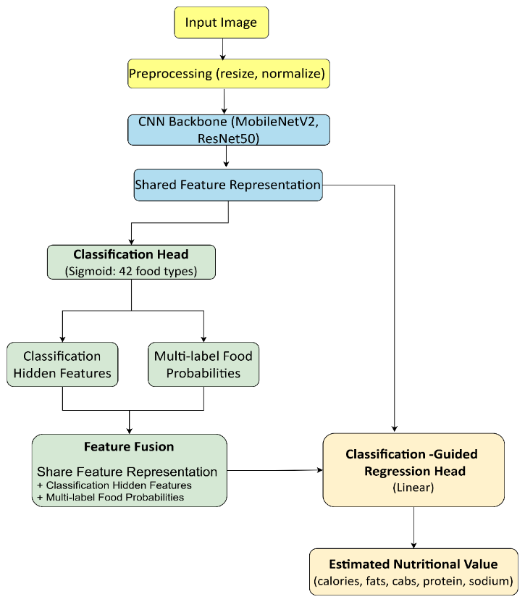
Fig. 1. The proposed flowchart for food image analysis and nutritional value estimation flow
2.2 Dataset
This study uses the NutritionVerse-Real dataset, an open-access, manually collected 2D food scene dataset for dietary intake estimation [5]. The original dataset contains 889 images across 251 distinct dishes and 45 unique food types. Each dish was photographed from multiple camera angles; up to four randomly selected viewpoints per dish were annotated, and images with labelling inconsistencies were subsequently removed, yielding the final 889 images. Each image is paired with a metadata file (nutritionverse_dish_metadata) containing dish_id, food_item_type, food weight (g), calories (kCal), fat (g), carbohydrates (g), protein (g), calcium (mg), iron (mg), magnesium (mg), potassium (mg), sodium (mg), vitamin D (µg), and vitamin B12 (µg) [5]. Of the 45 original food types, three classes with insufficient samples for salmon-nigiri, shrimp-nigiri, and tuna-nigiri were removed to maintain statistical significance, leaving 42 food classes used in this study. Fig. 2 shows the food-class distribution of the original data, and Fig. 3 provides example dishes from the dataset.
This dataset was selected because it is one of the few publicly available resources that pairs real 2D food images with both multi-label class annotations and comprehensive dish-level nutritional metadata, making it well suited for the joint food recognition and nutrition estimation tasks addressed in this study [5].
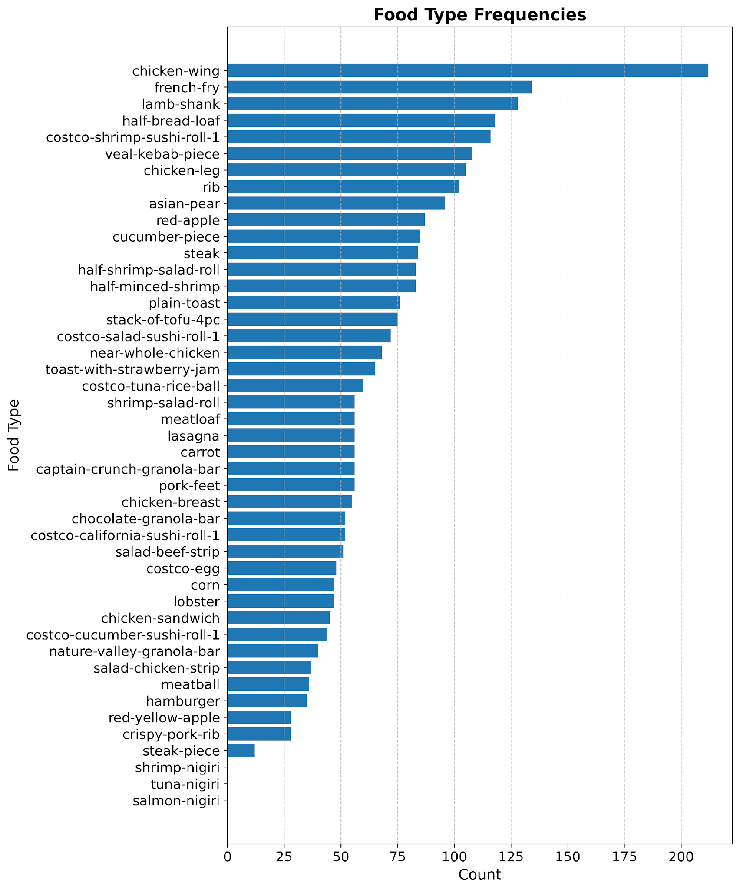Fig. 2. Food class distribution of original Data.
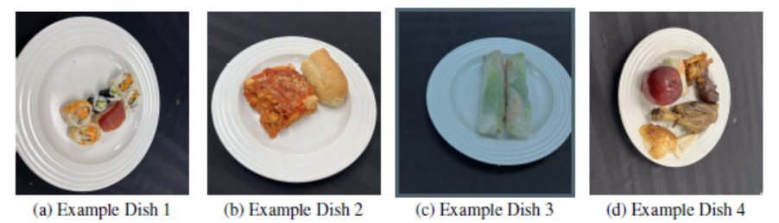
Fig. 3. Example dishes from NutritionVerse-Real
2.3 Feature Engineering and Data Preprocessing
The data were further processed to extract meaningful features and ensure suitability for model training. The dataset provides dish-level metadata, ingredient-level nutritional information, and corresponding food images [5]. Before model development, the raw data required systematic cleaning and restructuring to ensure consistency, reliability, and suitability for machine learning tasks [4, 6]. The preprocessing process was required to cover an end-to-end multi-task deep learning framework for simultaneous food recognition and nutrition estimation from food images.
2.3.1 Dataset Filtering and Final Sample Selection
The metadata file records up to seven food items per dish using variable-length columns. To standardize this for machine learning, a fixed list of 42 food types was curated to define the complete label space for multi-label classification. For each dish, missing values were replaced with empty strings, and a structured food-type vector was generated by incrementing corresponding columns whenever a match was found. This produced a cleaned dish-level metadata table containing only the dish_id and the 42 binaries food-type indicators.
To ensure the reliability of the training process, a systematic filtering step was performed to verify the presence of valid image references for every dish in the metadata. Images were loaded and verified using the Python Imaging Library (PIL); dishes lacking valid images were excluded to prevent mismatches. After cleaning incomplete classes and missing metadata, the study obtained 889 original images across 42 food classes. The final dataset includes multi-label annotations representing ingredient presence, along with comprehensive nutritional metadata including food weight (g), calories (kCal), fat (g), carbohydrates (g), protein (g), and various micro-nutrients such as calcium, iron, and vitamins. During this process, three specific classes with insufficient data; salmon-nigiri, shrimp-nigiri, and tuna-nigiri were removed to maintain statistical significance. Fig. 4 provides details of the food class distribution after dropping missing matches and refining the metadata.
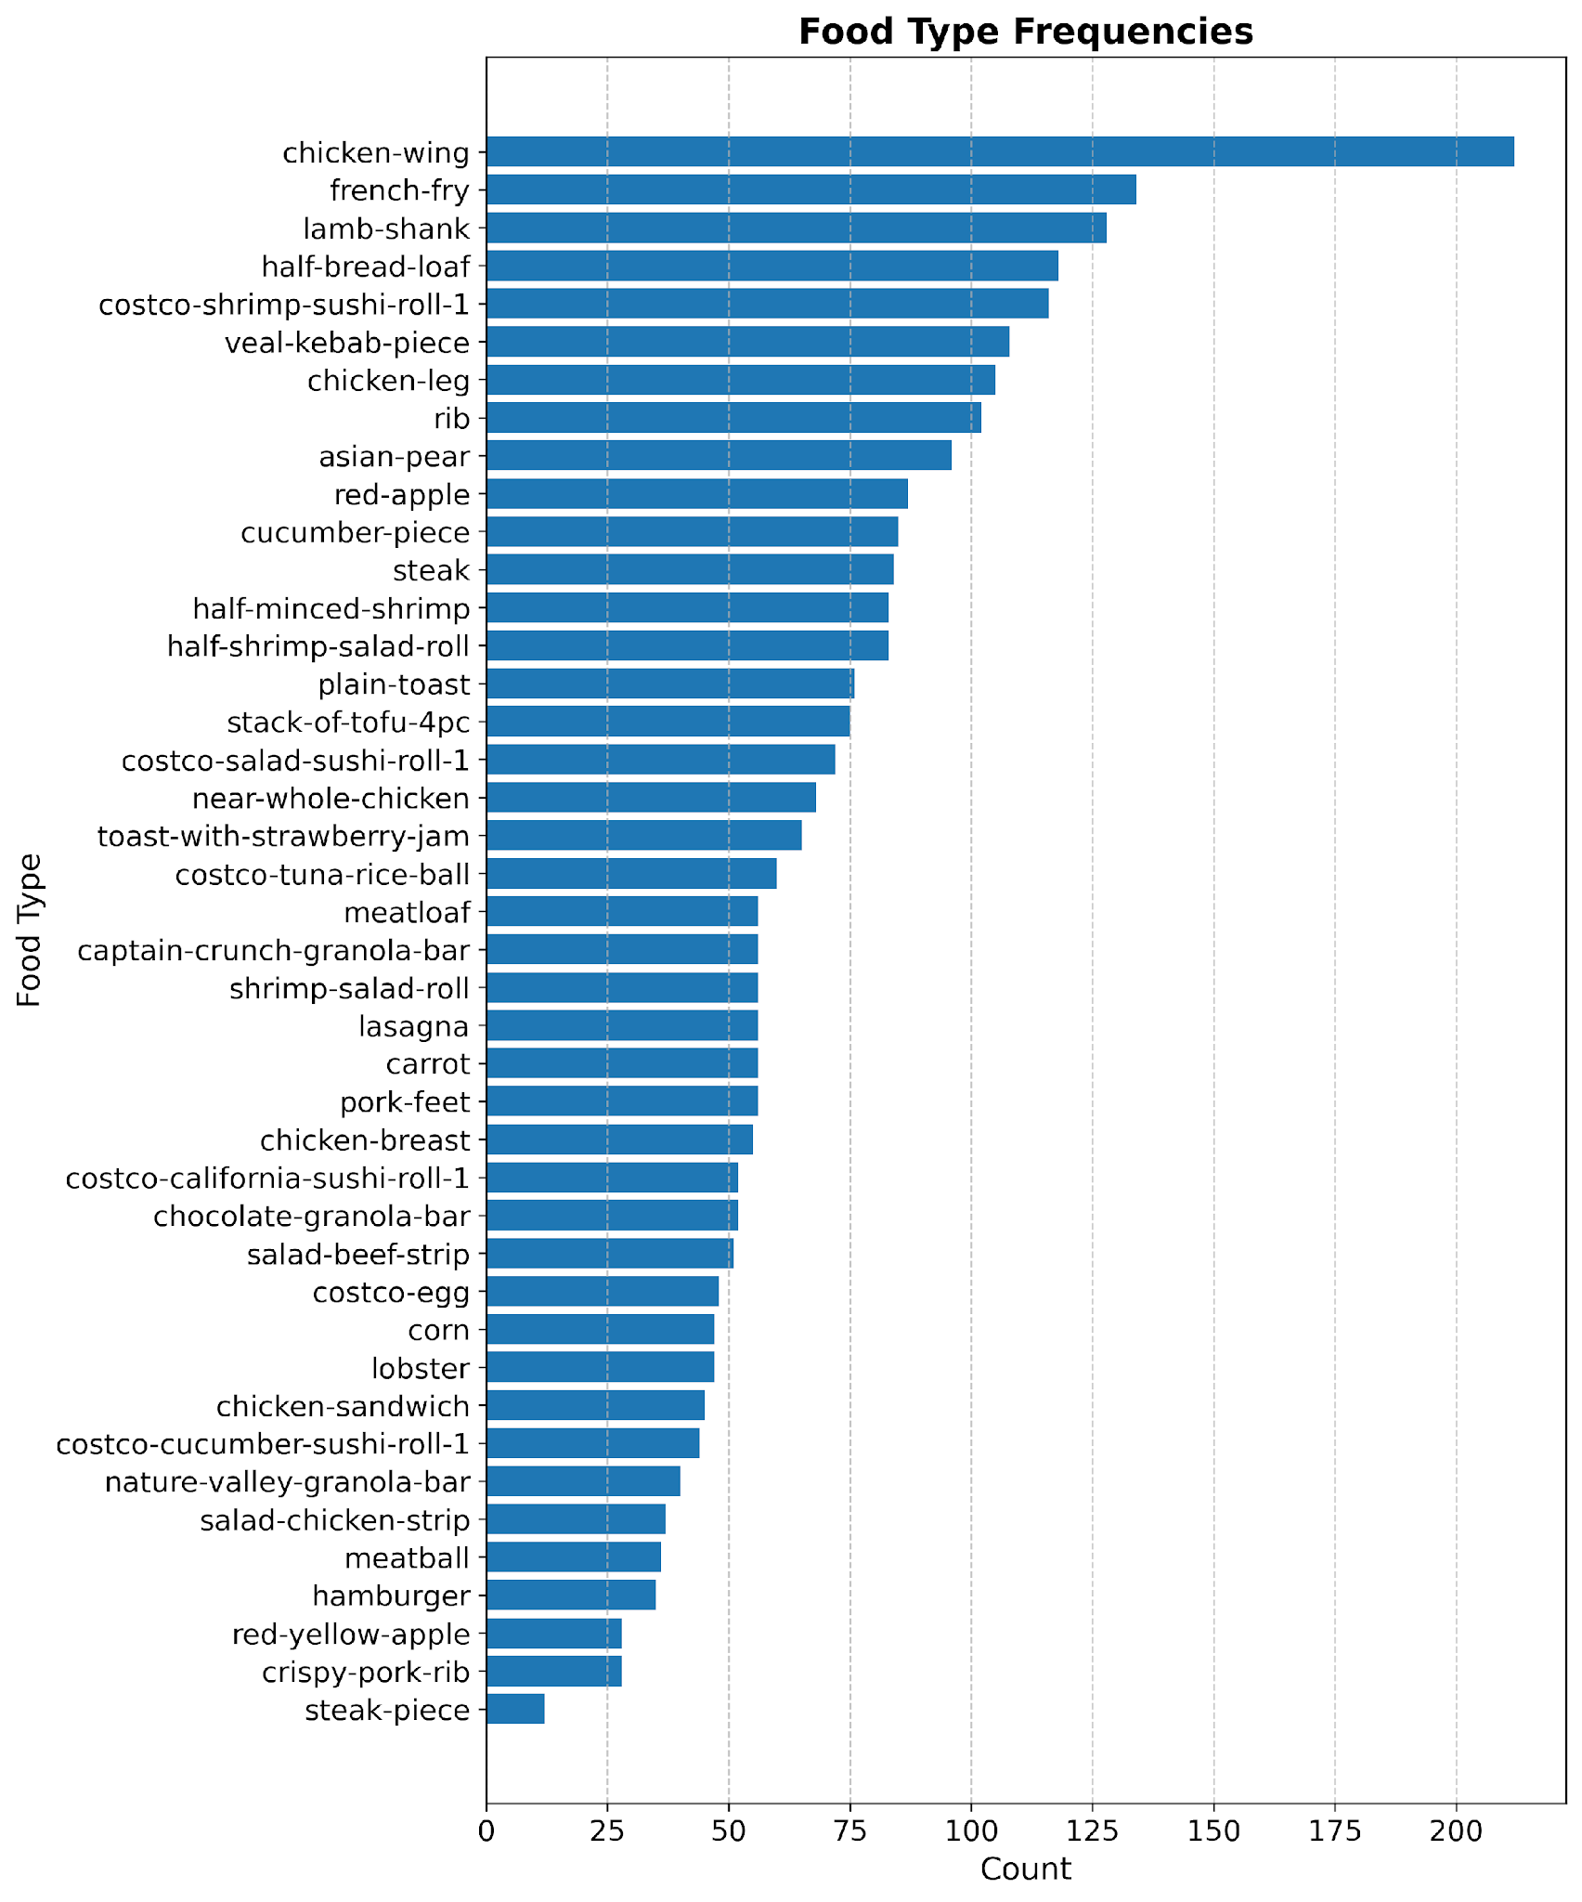
Fig. 4. Food class distribution after dropping the missing match.
2.3.2 Image-Based Feature Extraction and Dataset Filtering
Each dish in the dataset is associated with multiple food images captured from different viewpoints. However, for metadata-level feature extraction, only the presence of at least one valid image per dish was required. To incorporate basic visual characteristics, two global image features were extracted from the first available image associated with each dish: Aspect ratio is the proportional relationship between width and height and Average pixel intensity means the average value of all individual pixel intensities.

$$AR =\frac{Width}{Height}$$ | (Eq. 5)
$$API=\frac{1}{N}\sum_{i=1}^{N}{I_{i} }$$ | (Eq. 6)
Where,
$AR$is aspect ratio
$API$ is average pixel intensity
$N$ is total number of pixels
$I_{i}$ is intensity of pixel i
These features were included as supplementary image descriptors. However, their individual contribution to predictive performance was not separately evaluated, as the primary learning signal was derived from CNN-extracted visual features.
Images were loaded and verified using PIL. If no valid image was found for a given dish, that dish was excluded from further analysis to prevent mismatches between metadata and image data. After this filtering step, a cleaned metadata file generated, containing only dishes with valid image references. Each row in this file represents a single dish and includes:
- Dish identifier
- 42 food-type indicator columns
- Nutrition value of each 42 food-type indicator columns
- Aspect Ratio
- Average Pixel Intensity
This dataset serves as the foundation for an end-to-end multi-task deep learning framework for simultaneous food recognition and nutrition estimation from food images and data augmentation in later stages.
2.3.3 Data Augmentation
In this process, a target minimum of 30 training samples per food type was set. Food categories with fewer than this threshold were selected for augmentation. This threshold was chosen as a practical balance between improving class representation and avoiding excessive duplication of training data. Before performing any augmentation, the dataset was split into training (80%), validation (10%), and test (10%) sets at the dish level, yielding 711 training, 88 validation, and 90 test images rather than at the image level. Data augmentation was applied only to training images that contained minority food classes. For each minority class, existing training images were randomly sampled with replacement until the desired number of samples was reached. To prevent excessive duplication from a single source image, a maximum number of augmented images per original image was enforced. Each augmented image was generated by applying a random combination of the following transformations:
- Horizontal flipping, applied with a fixed probability
- Random rotation within a limited angular range
- Random zooming, followed by resizing to preserve original dimensions
- Brightness adjustment
After augmentation, class counts were recomputed for the training set to verify that minority food types met or exceeded the target sample threshold. A comparison of class frequencies before and after augmentation was generated to document the effectiveness of the balancing process. In addition, class weights were calculated based on the final class distribution. These weights were later used during model training to further mitigate residual imbalance by assigning higher loss penalties to underrepresented food types. In total, targeted augmentation added 62 images, increasing the training set from 711 to 773 images while the validation and test sets were left unchanged. Fig. 5 provides details of class frequency between training and testing sample.
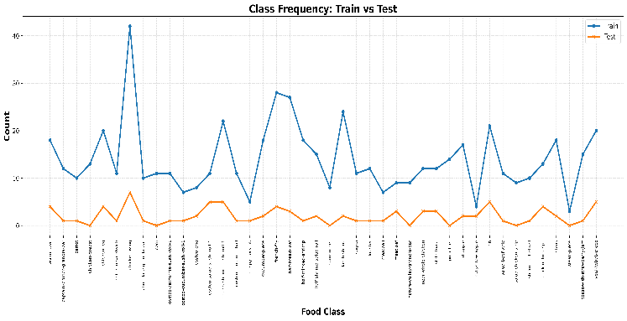
Fig. 5. Food class distribution frequency of training and testing.
2.4 Model Architecture
The proposed architecture follows a shared-feature multi-task design. A convolutional neural network backbone extracts image features, which are then fed into two parallel branches. The classification branch predicts the presence of food components using sigmoid activation, while the regression branch estimates nutritional values using fully connected layers. This design enables the model to leverage shared representations for both tasks, improving overall efficiency and learning performance.
2.4.1 MobileNetV2 Model
MobileNetV2 [8] was adopted as a lightweight and efficient feature extractor for the proposed multi-task learning framework. It contains approximately 3.4 million parameters and 0.3 billion multiply add operations (MACs) at a 224 × 224 input resolution, making it well suited for resource-constrained deployment [8]. Pretrained weights on ImageNet were utilized to leverage transfer learning, enabling the model to extract meaningful visual representations from food images despite the limited dataset size. The final classification layer of the MobileNetV2 was removed, and the remaining convolutional layers were used as a shared backbone. The extracted feature maps were passed through a global average pooling layer, followed by batch normalization and fully connected layers to generate compact feature embeddings. These shared features were then fed into two parallel branches:
- A multi-label classification head: consisting of fully connected layers with sigmoid activation, to predict the presence of multiple food items in a single dish.
- A regression head: combining the shared visual features with the predicted class probabilities (label-conditioned input) to estimate dish-level nutritional values.
During training, the model was conducted into two stages. In the first stage, MobileNetV2 backbone was fully frozen and only the two branch heads were trained, allowing the classification and regression layers to stabilize before any backbone weights were updated. In the second stage, the last 20 convolutional layers of the backbone were unfrozen and fine-tuned jointly with both heads at a lower learning rate, enabling the shared feature extractor to adapt progressively to the food image domain. Each branch is supervised by its own loss function: the classification head is trained with Weighted Binary Cross-Entropy (WBCE) where per-class weights are computed from the training distribution to penalize misclassification of minority food types and the regression head is trained with Huber loss, which balances sensitivity to small errors with robustness to outliers in the nutritional targets. To unify both objectives into a single training signal, these two losses are combined as defined in Eq. 2, with a classification-oriented balance of w₁ = 0.7 and w₂ = 0.3, and the regression loss further weighted per nutrient as defined in Eq. 4. This weighting ensures that the model prioritizes learning accurate food component identification, which in turn provides richer conditioning signals for the nutrition estimation branch.
2.4.2 ResNet50 Model
To compare performance with a deeper architecture, ResNet50 was implemented as an alternative backbone within the same multi-task framework. ResNet50 utilizes residual learning to facilitate deeper feature extraction while mitigating vanishing gradient issues. Similar to MobileNetV2, the original fully connected classification layer was removed, and the remaining convolutional layers served as a shared feature extractor. The extracted feature maps were processed through global average pooling and then fed into the same dual-branch architecture consisting of a multi-label classification head and a nutrition regression head. While ResNet50 offers greater representational capacity than MobileNetV2, it also introduces higher computational complexity and a substantially larger parameter count approximately 25.6 million parameters and 3.9 billion MACs, roughly 7.5× and 13× greater than MobileNetV2, respectively [8, 9].
During training, a two-stage transfer learning strategy was adopted. In the first stage, the ResNet50 backbone was fully frozen and only the classification and regression heads were trained. In the second stage, the last 30 convolutional layers of the backbone were unfrozen and fine-tuned jointly with both heads using a lower learning rate. The same combined loss function defined in Eq. 1 was used, but with a regression-oriented balance of w₁ = 0.3 and w₂ = 0.7 (Eq. 3) since the higher capacity ResNet50 required stronger regression emphasis to avoid negative R² values on the nutrition targets
2.5 Evaluation Metrics
Given the multi-label nature of the food recognition task, multiple evaluation metrics were employed to provide a comprehensive assessment of model performance. Traditional accuracy is not suitable in this context, as each image may contain multiple food items and class distributions are highly imbalanced.
For multi-label food recognition, performance was evaluated using micro precision, micro recall, micro F1-score, macro F1-score, Hamming accuracy, and the micro-averaged area under the ROC curve (AUC). Micro-averaged metrics reflect overall prediction performance across all labels, while macro F1-score highlights performance on less frequent classes. Hamming accuracy measures the proportion of correctly predicted labels. In addition, per-class precision, recall, and F1-scores were analyzed to examine class-specific behavior and identify challenging food categories.
Common evaluation metrics for non-classification prediction tasks, relevant to estimated nutritional values, include Mean Absolute Error (MAE), Root Mean Squared Error (RMSE), and the coefficient of determination (R²). For this paper, we explore all metrics; however, the R² is used to decide the best fit model. The equations (Eq.4-Eq.6) illustrate how all evaluation metrics are calculated.

 | $$MAE=\frac{1}{n}Σ_{i=1}^{n}\left|y_{i}-{\hat{y}}_{i}\right|$$ |  | (Eq.7)
 | $$RMSE=\sqrt{\frac{1}{n}Σ_{i=1}^{n}{\left(y_{i}-{\hat{y}}_{i}\right)}^{2}}$$ |  | (Eq.8)
 | $$R^{2}=1-\frac{\sum_{i=1}^{n}{{\left(y_{i}-{\hat{y}}_{i}\right)}^{2}}}{\sum_{i=1}^{n}{{\left(y_{i}-{\overline{y}}_{i}\right)}^{2}}}$$ |  | (Eq.9)
Where,
$n$ is the number of observations
$y_{i}$is the actual value at $i^{th}$ data point
${\hat{y}}_{i}$is the predicted value at $i^{th}$ data point
${\overline{y}}_{i}$is the mean of actual values

Before presenting the evaluation results, Table 1 summarizes the key hyperparameter configurations used to train both models. All hyperparameters were selected based on established practices for transfer learning on small-scale food datasets and validated through preliminary experiments on the held-out validation split. The two-stage training strategy comprising an initial frozen-backbone phase followed by selective fine-tuning was adopted to stabilize early training and prevent catastrophic forgetting of ImageNet-pretrained representations. Early stopping was applied in both stages, monitoring the multi-label AUC on the validation set to avoid overfitting given the limited dataset size.

Table 1. Hyperparameter Configuration for Model Training
Hyperparameter | MobileNetV2 | ResNet50
Input Image Size | 224 × 224 × 3 | 224 × 224 × 3
Optimizer | Adam | Adam
Learning Rate (Stage 1 – Frozen) | 1×10⁻⁴ | 1×10⁻⁴
Learning Rate (Stage 2 – Fine-Tune) | 1×10⁻⁵ | 1×10⁻⁵
Batch Size | 16 | 16
Epochs (Stage 1 – Frozen) | 12 | 10
Epochs (Stage 2 – Fine-Tune) | 8 | 6
Fine-Tuned Layers | Last 20 layers | Last 30 layers
Early Stopping Monitor | val AUC | val AUC
Early Stopping Patience | 4 epochs | 4 epochs
LR Reduction on Plateau | Factor 0.5, patience 2 | Factor 0.5, patience 2
Dropout Rate (Backbone Head) | 0.40 | 0.50
L2 Regularisation | 1×10⁻⁴ | 1×10⁻⁴
Classification Loss Weight (w₁) | 0.70 | 0.3
Regression Loss Weight (w₂) | 0.3 | 0.7
Pre-trained Weights | ImageNet | ImageNet
- RESULTS AND DISCUSSION
3.1 Food Recognition Performance
Table 2 summarizes the key food recognition metrics for both models on the test set. The results confirm that both architectures can learn meaningful multi-label representations from food images, while also highlighting the difficulty of achieving high exact match accuracy on complex dish compositions. Macro F1-score, which reflects average per-class performance, was notably lower than Micro F1-score for both models, indicating that rare food categories continue to represent the primary challenge in this multi-label food recognition task.

Table 2. Food Recognition Performance
Metric | MobileNetV2 | ResNet50
Hamming Accuracy | 0.9132 | 0.9071
Micro Precision | 0.5034 | 0.4715
Micro Recall | 0.4545 | 0.5273
Micro F1-Score | 0.4777 | 0.4979
Macro F1-Score | 0.3414 | 0.3905
Micro AUC | 0.8938 | 0.8929

Fig. 6 shows the per-class F1-score distribution for MobileNetV2. Considerable variation in performance can be observed across food categories, with a small number of classes achieving high F1-scores and many classes exhibiting relatively low performance. This variability contributed to the model's Macro F1-score of 0.3414.

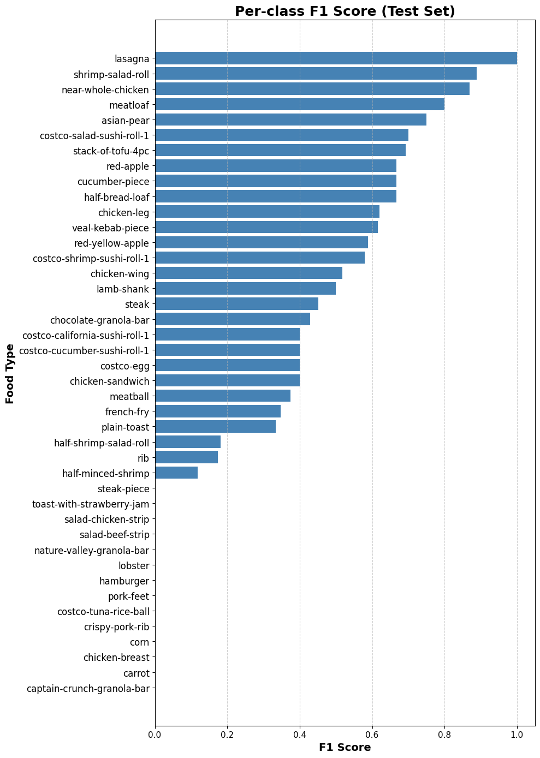
Fig. 6. Per Class F1-Score of MobileNetV2
Fig. 7 presents the per-class F1-score distribution for ResNet50. Compared with MobileNetV2, ResNet50 achieved a more balanced distribution of F1-scores across food categories, resulting in a higher Macro F1-score of 0.3905 and improved class-level recognition performance.

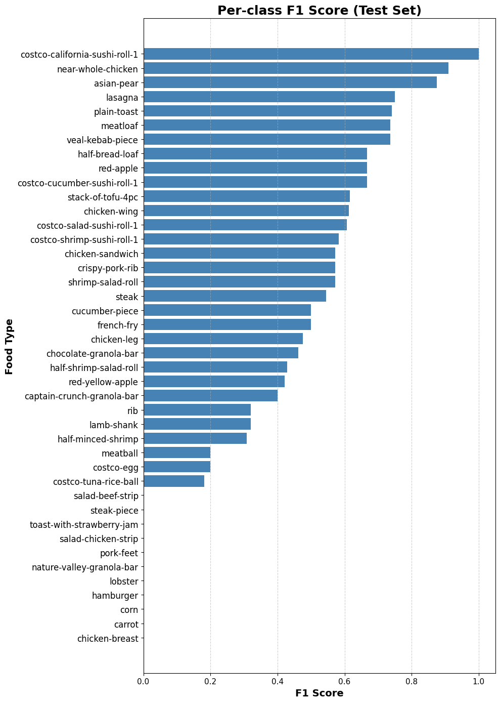
Fig. 7. Per Class F1-Score of ResNet50
To further investigate the variation in class-level performance, the top- and bottom-performing food classes for both architectures are presented in Tables 3 to Table 6.
Table 3 presents the ten highest-performing food classes for MobileNetV2 based on class-wise F1-score. Most of these classes achieved relatively high recognition performance as they exhibit distinctive visual characteristics, such as unique shapes, colors, or textures, making them easier for the model to differentiate from other food categories.

Table 3. Top 10 Performing Food Classes for MobileNetV2
Food Class | F1 Score
Lasagna | 1.00
Shrimp-salad-roll | 0.89
Near-whole-chicken | 0.86
Meatloaf | 0.80
Asian-pear | 0.74
Costco-salad-sushi-roll-1 | 0.70
Stack-of-tofu-4pc | 0.69
Red-apple | 0.67
Cucumber-piece | 0.67
Half-bread-loaf | 0.67

Table 4 summarizes the ten lowest-performing food classes for MobileNetV2. These classes achieved F1-scores close to zero, indicating that the model struggled to correctly identify them. Possible contributing factors include limited training samples, class imbalance, and visual similarities with other food categories.
Table 4. Bottom 10 Performing Food Classes for MobileNetV2
Food Class | F1 Score
Captain-crunch-granola-bar | 0.00
Carrot | 0.00
Chicken-breast | 0.00
Corn | 0.00
Crispy-pork-rib | 0.00
Pork-feet | 0.00
Hamburger | 0.00
Lobster | 0.00
Nature-valley-granola-bar | 0.00
Salad-beef-strip | 0.00

Table 5 shows the ten highest-performing food classes for ResNet50. Similar to MobileNetV2, classes with distinctive visual appearances achieved higher F1-scores, demonstrating the ability of deeper convolutional architectures to learn discriminative visual features for food recognition.

Table 5. Top 10 Performing Food Classes for ResNet50
Food Class | F1 Score
Costco-california-sushi-roll-1 | 1.00
Near-whole-chicken | 0.91
Asian-pear | 0.87
Lasagna | 0.74
Plain-toast | 0.74
Meatloaf | 0.73
Veal-kebab-piece | 0.73
Half-bread-loaf | 0.67
Red-apple | 0.67
Costco-cucumber-sushi-roll-1 | 0.67

Table 6 presents the ten lowest-performing food classes for ResNet50. Despite achieving a higher overall Macro F1-score than MobileNetV2, ResNet50 continued to struggle with several underrepresented or visually ambiguous classes, resulting in zero F1-scores for the below food class.

Table 6. Bottom 10 Performing Food Classes for ResNet50
Food Class | F1 Score
Chicken-breast | 0.00
Carrot | 0.00
Corn | 0.00
Hamburger | 0.00
Lobster | 0.00
Nature-valley-granola-bar | 0.00
Pork-feet | 0.00
Salad-chicken-strip | 0.00
Toast-with-strawberry-jam | 0.00
Steak-piece | 0.00

Both MobileNetV2 and ResNet50 achieved strong performance on visually distinctive food categories but struggled with several minority classes. The consistent occurrence of near-zero F1-scores for classes such as chicken-breast, carrot, corn, and pork-feet across both architectures suggests that class imbalance and visual similarity had a greater impact on performance than the choice of backbone model. Although ResNet50 improved the Macro F1-score from 0.3414 to 0.3905, further improvements may require larger datasets, class-balanced learning strategies, and advanced augmentation techniques.

3.2 Dish-Level Nutrition Estimation Performance
The regression head in both models was designed to receive concatenated features from the shared backbone, the classification hidden layer, and the classification output probabilities. This joint conditioning allows the regression branch to leverage food composition predictions as a prior, which is conceptually aligned with how nutritional content relates to the types of food present in a dish. Despite this architectural benefit, the R² values for calories, fats, and protein remained limited, suggesting that the visual signal from 2D images does not fully capture portion-related variance, which is a well-known limitation in image-based nutrition estimation.
Table 7 presents the regression evaluation results for both MobileNetV2 and ResNet50 across all five nutritional targets. Under the backbone-specific task-loss weighting described in Section 2.4, MobileNetV2 achieved positive R² values across all five nutritional targets, ranging from 0.173 for calories to 0.613 for sodium, with fats ($R^{2}=0.190$) and carbohydrates ($R^{2}=0.279$) as the next strongest targets and protein ($R^{2}=0.054$) the weakest. ResNet50 achieved comparable or stronger regression performance for three of the five nutrients, sodium ($R^{2}=0.691$), carbohydrates ($R^{2}=$0.290), and protein ($R^{2}=$0.072) while remaining weaker than MobileNetV2 for fats ($R^{2}$ = 0.049) and comparable for calories ($R^{2}$ = 0.166). No negative R² values were observed for either backbone.
The remaining regression error can be largely attributed to the inherent challenges of estimating nutritional content from a single 2D food image. Nutritional values are strongly influenced by portion size and food quantity, which cannot be directly observed from monocular images. Previous studies have reported that the absence of three-dimensional information limits accurate portion estimation [2], while more recent approaches have incorporated depth prediction and volume-related features to improve nutrition estimation accuracy [3]. Although the proposed architecture leverages food classification outputs as conditioning signals for nutrition estimation, accurate food recognition alone is insufficient to recover portion-related information. This is illustrated by ResNet50: despite achieving stronger classification metrics than MobileNetV2 (Table 2), its regression performance under classification-dominant weighting was unstable, and only improved to a level comparable with or exceeding MobileNetV2 once its loss weighting was rebalanced toward the regression objective (Table 7). This indicates that, in this framework, stronger classification alone does not automatically transfer to better nutrition estimation the balance between the two task-specific losses must be tuned independently for each backbone.

Table 7. Dish-Level Nutrition Estimation Performance
Nutrient | MobileNetV2 |  | ResNet50
Nutrient | MAE | R² | MAE | R²
Calory (kCal) | 634.30 | 0.173 | 631.36 | 0.166
Fats (g) | 35.58 | 0.190 | 35.31 | 0.049
Carbs (g) | 49.78 | 0.279 | 49.01 | 0.290
Protein (g) | 59.58 | 0.054 | 54.68 | 0.072
Sodium (mg) | 0.38 | 0.613 | 0.35 | 0.691

3.3 Overall Discussion

Both models were evaluated holistically across two interlinked tasks: multi-label food recognition and dish-level nutrition regression. The combined loss function used during training is a weighted sum of Weighted Binary Cross-Entropy for classification and Huber loss for regression, with the relative weighting tuned independently for each backbone rather than fixed: classification-dominant ($w_{1}$= 0.7, $w_{2}$= 0.3) for MobileNetV2, and regression-dominant ($w_{1}$= 0.3, $w_{2}$= 0.7) for ResNet50. This backbone-specific weighting reflects the finding that the optimal balance between the two objectives depends on a backbone’s capacity relative to the available training data, rather than being a universal fixed ratio.
Overall, neither backbone was uniformly superior across both tasks. MobileNetV2 remained the stronger and more lightweight option for classification-leaning use cases, while also achieving positive regression performance across all five nutritional targets. ResNet50, once given a regression-dominant loss weighting, matched or exceeded MobileNetV2 on three of the five nutrients (sodium, carbohydrates, and protein) while trading some classification precision for higher recall and F1-score (Table 2). This indicates that ResNet50’s larger capacity is not inherently disadvantageous for this task, but that realizing its benefit for regression requires explicitly rebalancing the loss toward the regression objective; under the classification-dominant weighting originally used for both backbones, ResNet50’s regression branch instead overfit the limited training data. Fig. 8 presents the sample result for dish ID 202 of our multi-task models, both MobileNetV2 and ResNet50.
Direct numerical comparison with prior published work is limited by differences in datasets and task formulation, but some context can be drawn. Wimalasiri and Sahoo [4] reported a mean average precision of 83.4% and $R^{2}$of 0.986 for food weight estimation on a 14-class, single-label dataset of 2,380 images; the substantially higher $R^{2}$ reflects a simpler single-target weight-regression task on a larger, more homogeneous dataset, rather than indicating that their approach is more effective than the present multi-label, five-nutrient framework evaluated here on a smaller and more class-diverse dataset (889 images, 42 classes). He et al. [11] combined food recognition and portion-size estimation in a similar multi-task formulation and reported a classification accuracy of 6.2% alongside a portion-regression MAE of 14.8g on a 30-class dataset, illustrating that joint recognition-and-quantity estimation remains difficult across independent studies and datasets, consistent with the moderate regression performance observed in the present work. These comparisons suggest that the relative difficulty of multi-label, multi-nutrient estimation from 2D images rather than a shortcoming specific to either backbone evaluated here is the dominant factor limiting absolute regression accuracy across the field, underscoring the need for standardized benchmarks in this area.
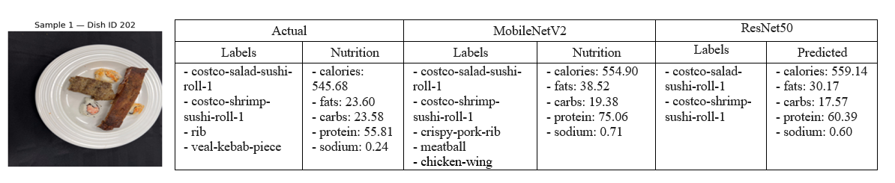
Fig. 8. Sample Output for Dish ID 202
- CONCLUSIONS
The experimental results demonstrate that both backbones can achieve stable, positive nutrition estimation once each is assigned its own classification/regression loss weighting rather than a single fixed ratio. MobileNetV2 achieved a Hamming Accuracy of 0.9132, Micro Precision of 0.5034, and Micro Recall of 0.4545 on the food recognition task, together with positive $R^{2 }$values across all five nutritional targets, ranging from 0.173 for calories to 0.613 for sodium. ResNet50 achieved a higher Micro Recall of 0.5273 and Micro/Macro F1-scores of 0.4979/0.3905, and matched or exceeded MobileNetV2’s regression performance for three of the five nutrients ($R^{2}$ of 0.691 for sodium, 0.290 for carbohydrates, and 0.072 for protein), with no negative $R^{2}$values for either backbone. These results indicate that the optimal balance between classification and regression objectives in multi-task learning is backbone-dependent rather than fixed, and that a larger model is not inherently disadvantaged for multi-task learning on small-scale food datasets provided its loss weighting is tuned accordingly.
Key contributions of this work include the development of a multi-task architecture that conditions nutritional regression on food classification outputs, enabling the regression branch to leverage ingredient-level predictions as contextual priors; the use of backbone-specific classification/regression loss weighting, which resolved unstable regression performance observed under a single fixed weighting shared across backbones; the application of targeted data augmentation exclusively to minority food classes to address class imbalance without contaminating validation and test splits; and the adoption of per-class threshold calibration on the validation set to optimize multi-label decision boundaries beyond a single global threshold. These design decisions collectively contributed to a more robust and practically applicable food analysis system.
The primary limitation of this work is the absence of depth and portion size information, which constrains the accuracy of nutritional regression particularly for high-variance macronutrients such as calories and fats. The evaluation is also based on a single train/validation/test split over a comparatively small test set (23 dishes); future work should apply k-fold cross-validation or repeated random splits with significance testing to confirm that differences between backbones are robust rather than attributable to a particular split. Formal benchmarking of inference latency and on-device model size is also left to future work to substantiate efficiency claims beyond parameter count alone. Future work should further explore the integration of depth estimation modules or stereo-image inputs to incorporate volumetric information, the collection of a dedicated Cambodian or Southeast Asian food dataset to complement the predominantly Western food classes used in this study, and the application of dynamic multi-task loss balancing methods to automate the backbone-specific weight selection performed manually here. Transfer learning from richer food datasets or incorporating large-scale vision-language models as feature extractors also represents a promising direction for enhancing both recognition accuracy and nutritional estimation reliability.
Beyond its technical contributions, this framework aligns with and supports several United Nations Sustainable Development Goals (SDGs). Most directly, it contributes to SDG 3 (Good Health and Well-Being) by enabling automated, accessible dietary monitoring that can help individuals make more informed nutritional choices and reduce the risk of diet-related non-communicable diseases. It also relates to SDG 2 (Zero Hunger) by advancing the technological infrastructure needed for food intake awareness and nutritional equity, particularly in under-served Southeast Asian communities where reliable dietary data is scarce. Furthermore, the comparatively small size of the MobileNetV2 backbone (3.4 million parameters) suggests potential for future mobile deployment and supports SDG 9 (Industry, Innovation and Infrastructure); realizing this potential in practice will require the latency and on-device benchmarking noted above. This framework therefore lays a practical groundwork for automated dietary monitoring systems that could support healthier lifestyle decisions in real-world mobile applications, with meaningful potential for positive societal impact across the region.

ACKNOWLEDGMENTS
My sincere appreciation and deepest gratitude extend to Dr. Sokkhey PHAUK and Dr. Sothea HAS for their invaluable support throughout this research. Their profound insights, exceptional expertise, and unwavering encouragement with great patience, were instrumental in not only completing this work, but also in fostering a comprehensive understanding of the subject matter. Their supervision has been a great source of direction, and I am honored to have had the opportunity to contribute to this project under their supervision.

REFERENCES
[1] World Health Organization. (2020). Healthy diet. Retrieved from https://www.who.int/news-room/fact-sheets/detail/healthy-diet Accessed: June 2026
[2] Z. Shao, S. Fang, R. Mao, J. He, J. L. Wright, D. A. Kerr, C. J. Boushey, and F. Zhu, "Towards Learning Food Portion From Monocular Images With Cross-Domain Feature Adaptation," in Proc. IEEE 23rd International Workshop on Multimedia Signal Processing (MMSP), 2021, pp. 1–6. doi: 10.1109/MMSP53017.2021.9733557.
[3] Y. Han, Q. Cheng, W. Wu, and Z. Huang, "DPF-Nutrition: Food nutrition estimation via depth prediction and fusion," Foods, vol. 12, no. 23, p. 4293, 2023, doi: 10.3390/foods12234293.
[4] C. Wimalasiri and P. K. Sahoo, "Vision-based approach for food weight estimation from 2D images," arXiv preprint arXiv:2405.16478, 2024.
[5] C. E. A. Tai, S. Nair, O. Markham, M. Keller, Y. Wu, and A. Wong, "NutritionVerse-Real: An open access manually collected 2D food scene dataset for dietary intake estimation," arXiv preprint arXiv:2310.02103, 2023.
[6] A. Oguntimilehin and G. O. Toyin, "Deep Learning-Based Food Calorie Estimation System for Dietary Tracking," 2024 IEEE 5th NIGERCON, pp. 1–6, Nov. 2024.
[7] P. Queipo-Alvarez et al., “Food Calorie Estimation Using Computer Vision: A Comparative Review of Models and Approaches,” Malaysian Journal of Medicine and Health Sciences, vol. 21, no. SUPP11, pp. 194-201, Nov. 2025.
[8] M. Sandler, A. Howard, M. Zhu, A. Zhmoginov, and L.-C. Chen, "MobileNetV2: Inverted Residuals and Linear Bottlenecks," in Proc. IEEE/CVF CVPR, pp. 4510–4520, 2018. doi: 10.1109/CVPR.2018.00474
[9] K. He, X. Zhang, S. Ren, and J. Sun, "Deep Residual Learning for Image Recognition," in Proc. IEEE CVPR, pp. 770–778, 2016. doi: 10.1109/CVPR.2016.90
[10] S. Rokhva, B. Teimourpour, and A. H. Soltani, "Computer Vision in the Food Industry: Accurate, Real-Time, and Automatic Food Recognition with Pretrained MobileNetV2," Food Humanit., vol. 3, p. 100378, 2024. doi: 10.1016/j.foohum.2024.100378
[11] J. He et al., "Multi-Task Image-Based Dietary Assessment for Food Recognition and Portion Size Estimation," in Proc. IEEE MIPR, pp. 49–54, 2020. doi: 10.1109/MIPR49039.2020.00017
[12] A. O. Adegbenjo and M. O. Ngadi, "Handling the Imbalanced Problem in Agri-Food Data Analysis," Foods, vol. 13, no. 20, Art. no. 3300, 2024. doi: 10.3390/foods13203300.
[13] F. P. W. Lo, Y. Sun, J. Qiu, and B. Lo, "Image-Based Food Classification and Volume Estimation for Dietary Assessment: A Review," IEEE Journal of Biomedical and Health Informatics, vol. 24, no. 7, pp. 1926–1939, Jul. 2020. doi: 10.1109/JBHI.2020.2987943.
[14] G. A. Tahir and C. K. Loo, "A Comprehensive Survey of Image-Based Food Recognition and Volume Estimation Methods for Dietary Assessment," Healthcare, vol. 9, no. 12, Art. no. 1676, 2021. doi: 10.3390/healthcare9121676.
[15] K. V. Dalakleidi, M. Papadelli, I. Kapolos, and K. Papadimitriou, "Applying Image-Based Food-Recognition Systems on Dietary Assessment: A Systematic Review," Advances in Nutrition, vol. 13, no. 6, pp. 2590–2619, 2022. doi: 10.1093/advances/nmac078.

* Corresponding author: E-mail: ; Tel: +

